Full Paper Title in Title Case

Name Surname^{1*} [ORCID] and Name Surname² [ORCID]
International Human Resource Management & Development, Naresuan University International College, Naresuan University, Phitsanulok, 65000, Thailand
Email: First.Author@nu.ac.th

Department/Affiliation, Address, City, Country²
E-mail: Second.Author@kku.ac.th
ABSTRACT
This document outlines the formatting specifications for the 10th Thailand International College Consortium (TICC 2026) hosted by Naresuan University International College (NUIC), Phitsanulok, Thailand. It provides comprehensive instructions for styling text, table captions, and references, alongside guidance for incorporating indexing information and optimizing content for a global academic audience. All submissions must be prepared in Microsoft Word (.docx) format in strict accordance with these guidelines. Accepted papers will be published in the electronic conference proceedings. Please note that while initial submissions must be in Word, manuscripts will be converted to Portable Document Format (PDF) during the final publication stage. An abstract not exceeding 250 words should appear on the top of the first page, after the title of the paper in a section titled "ABSTRACT" (without section number), after the names of the authors. A selection of papers will be shortlisted for submission to indexed partner journals, where they will undergo a formal peer-review process for publication

KEYWORDS: 3-5 words

INTRODUCTION
Authors are expected to submit manuscripts that have been meticulously written and proofread for clarity, spelling, and grammatical accuracy. Submissions should be between 10 and 15 pages in length and must be written in English using SI units.

Each paper must provide a comprehensive background of the subject matter and a clear description of the research, including the methodology, results, and a concluding discussion on the work's significance. Technical terminology should be defined unless the terms are standard within the conference community.

PAPER FORMAT
To ensure a professional and uniform appearance for the conference proceedings, authors are encouraged to use this document as a template for their manuscripts. Adhering to these specifications will provide a consistent aesthetic and enhance readability across the entire publication. Manuscripts must use American Letter format with uniform 25 mm margins on all sides (top, bottom, left, and right).
Paragraph Styling: All body text should be single-spaced with a 10 mm first-line indent. Do not include additional spacing between paragraphs.
Headings & Subheadings: The positioning and style of headings must mirror this template. Use double spacing exclusively before and after headings and subheadings to ensure clear section transitions.

Header, Footer, Page Numbering
Authors are asked to replace the "XXX" number (with the paper code that was assigned when the paper was accepted) on the header of the first page and on the footer of other pages in order to set a unique page number in the Proceedings.

Fonts
Manuscripts should be set in 11-point Times New Roman font. While bold, italic, and underlined styles are permitted, they should be used judiciously to maintain professional clarity. For all figures and illustrations, please ensure that any embedded text maintains a minimum font size of 10-point to guarantee legibility in the final publication.

Tables and Figures
Captions and headings must be self-explanatory, allowing the reader to understand the data or imagery without cross-referencing the main body of the text. Furthermore, every figure and table included in the manuscript must be explicitly cited within the text; any unreferenced visual aids should be removed.
An example of the required formatting for Table 1 is provided below.
Table 1 Title of the Table
Type of nanoparticles | Average size (nm) | Variance (nm)
CuO | 47 | 4.2
NiO | 35 | 6.4
Al₂O₃ | 42 | 2.1
SnO₂ | 27 | 3.9

Tables and figures should be placed close after their first reference in the text. All figures and tables should be numbered with Arabic numerals. Table headings should be centred above the tables. Figure captions should be centred below the figures as shown in Figure 1.

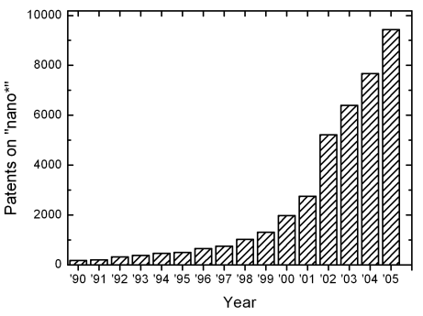
Figure 1: Number of patents on nanotechnology with time

Equations
Each equation should be presented on a separate line from the text with a blank space above and below. Equations should be clear and expressions used should be explained in the text. The equations should be numbered consecutively at the outer right margin, as shown in Eqs. (1) - (2) below. Here is one example.
In this case, the governing system of equations can be written as follows:
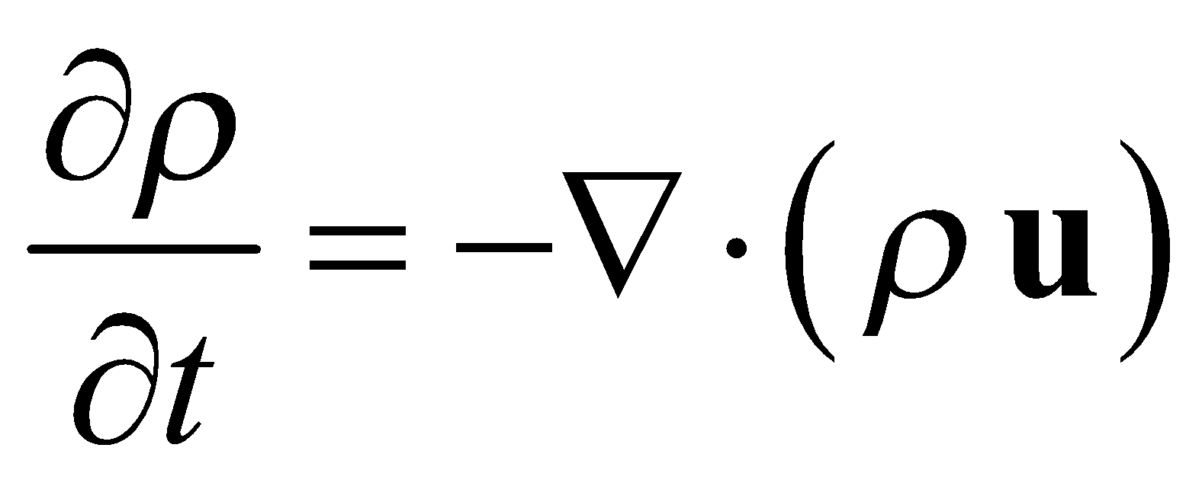 (1)
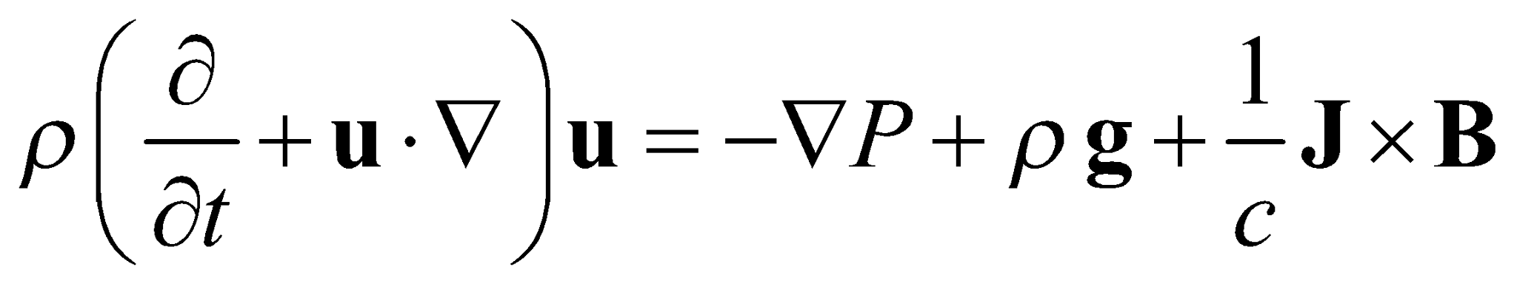 (2)
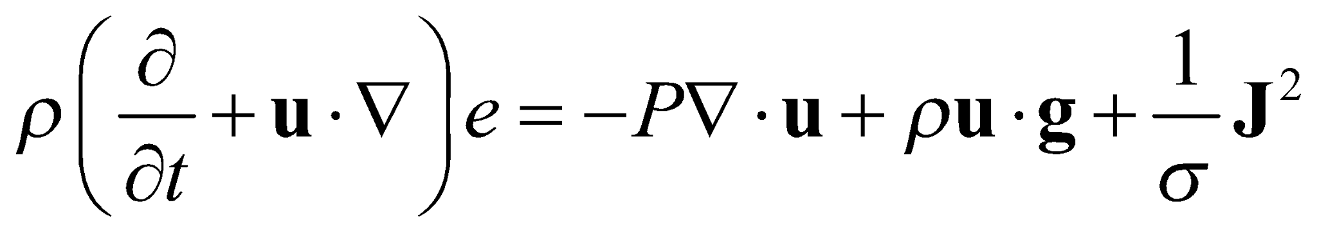 (3)

References
Authors must provide appropriate citations within the body of the manuscript and a comprehensive reference list in this section. Both in-text entries and the reference list must conform to the following standards:
Reference citations: Citations in the main body, appendices, tables and figures are to be made using the last name of the author (both authors when only two; first author plus et al. when more than two). Example: "... as previously shown (Jones et al., 1989)," or "... as shown by Jones et al. (1989)." For two or more papers published in the same year by the same author(s), add a, b, c, etc. to the year, such as (1980a) or (1980b) and cite jointly as Jones et al. (1980a, b).
List of references: List all cited references (including citations in tables, figures and appendices) in alphabetical order according to the first-named author. The titles of papers, patents and books or monograph chapters and the initial and final page numbers are to be included. Abbreviations of journal names should conform to the usage of Chemical Abstracts. Examples for journal papers, book/monograph sections or chapters, and conference proceedings are given in the reference section at the end of this document.
Referencing websites: With the increasing availability of useful information that can be found on the internet, website references must also be reported. At the end of the reference list, make a separate section of websites and the date consulted. However, to avoid very long website addresses, these references should be referred to as Web-1, Web-2, etc. For example, in the body of the report: “… it was shown that the heat transfer coefficient of nanofluids increased by 40% (Web-1) …”. In the reference list, provide the list of websites with the numeral values used in the text.

SUBMITTING THE PAPER
The full paper has to be submitted electronically via the website of the 10th TICC Conference (https://ticc10th.nu.ac.th/) by September 30, 2026.

CONFERENCE PROGRAM AND PROCEEDINGS
The extended abstracts and full manuscripts are compiled into the online conference proceedings.

CONCLUSION
The conclusion should succinctly summarize the paper's primary contributions and findings. Additionally, it should articulate the author’s perspective on the practical applications and real-world implications of the research results.

ACKNOWLEDGEMENTS
An optional Acknowledgements section may be included between the conclusion and the reference list. This section should be used to disclose sponsorship, financial support, and grants. Additionally, authors should recognize the contributions of colleagues who provided assistance but do not meet the criteria for authorship. If there are no specific contributions or funding to declare, this section should be omitted from the manuscript.
REFERENCES
Expert A. and Expert B.C. (2025). Sustainable Workforce Management in the Digital Era. Nature Sustainability and Nature Climate Change, 58, 171–176.
Hall B. and Maisonneuve M. (2024). The Nature of Nanofiltration Membrane Porosity," in "Proc. 2nd Int. Conf. Sep. Sci. Technol.," M.H. Weir and S. Vijay, Eds., Toronto, ON, Canada, October 1–4, 2007, pp. 36–43.
Plan Z.A., Lin R.T. and Richer J.A. Nanotechnology Devices. in "The World of Nanotechnology," G.E. Goodfellow and A.T. Mann, Eds., Butterworth Publishers, Boston, MA (1989), pp. 61–67.

